Example: Complete Report (ALV Interactive Reporting using classes)
Events covered: DOUBLE_CLICK, BUTTON_CLICK, HOTSPOT_CLICK
Features:- Specific Cell styling (Cell buttons), Row coloring, Excluding Std. ALV toolbar Buttons, Excluding ALV Toolbar, Field catalog generation using F.M & Manually, Field-symbol work area
REPORT Z930ALV3.
*tables kna1. "creates work area with all fields of kna1-not recommended
*select-options so_kunnr for kna1-kunnr. "(or)
data v_kunnr type kna1-kunnr.
select-options so_kunnr for v_kunnr DEFAULT '1000' to '1010'.
data : kna1_cont type ref to cl_gui_custom_container,
kna1_grid type ref to cl_gui_alv_grid,
vbak_cont type ref to cl_gui_custom_container,
vbak_grid type ref to cl_gui_alv_grid,
vbap_cont type ref to cl_gui_custom_container,
vbap_grid type ref to cl_gui_alv_grid.
types : begin of ty_kna1.
include type zckna1.
types end of ty_kna1.
data : t_kna1 type STANDARD TABLE OF ty_kna1,
wa_kna1 type ty_kna1.
types : begin of ty_vbak.
include type zcvbak.
types : netwr type vbak-netwr,
end of ty_vbak.
data : t_vbak type table of ty_vbak,
wa_vbak type ty_vbak.
types : begin of ty_final_vbak.
include type zcvbak.
types : netwr type vbak-netwr,
cellstyle type lvc_t_styl,
end of ty_final_vbak.
data : t_final_vbak type table of ty_final_vbak,
wa_final_vbak type ty_final_vbak.
types : begin of ty_vbap.
include type zcvbap.
types : rowcolor(4) type c,
end of ty_vbap.
data : t_vbap type table of ty_vbap,
wa_vbap type ty_vbap.
FIELD-SYMBOLS <fwa> like line of t_vbap.
data wa_styl type lvc_s_styl.
data wa_layo type lvc_s_layo.
data : t_fcat type lvc_t_fcat,
wa_fcat type lvc_s_fcat.
data : t_functions type ui_functions,
v_function type ui_func.
class lcl_eventreceiver DEFINITION.
public section.
methods handle_double_click
for event double_click
of cl_gui_alv_grid
IMPORTING e_row e_column.
methods handle_button_click
for event button_click
of cl_gui_alv_grid
IMPORTING es_col_id es_row_no.
methods handle_hotspot_click
for event hotspot_click
of cl_gui_alv_grid
importing e_row_id.
endclass.
class lcl_eventreceiver IMPLEMENTATION.
method handle_double_click.
case e_column-fieldname.
when 'KUNNR'.
* message 'double clicked on customer' type 'I'.
* extract interacted customer no
clear wa_kna1.
read table t_kna1 into wa_kna1 index e_row-index
TRANSPORTING kunnr.
if sy-subrc eq 0.
* get sales orders for selected customer
perform getvbak.
if t_final_vbak is not INITIAL. "if sales orders are available
call screen 200.
else.
message 'No sales orders for selected customer' type 'I'.
endif.
endif.
when others.
message 'Please double click on customer' type 'I'.
endcase.
endmethod.
method handle_button_click.
case es_col_id-fieldname.
when 'VBELN'.
* message 'button click' type 'I'.
clear wa_final_vbak.
read table t_final_vbak into wa_final_vbak
index es_row_no-row_id TRANSPORTING vbeln.
if sy-subrc eq 0.
* get sales items for selected sales order
perform getvbap.
if t_vbap is not INITIAL.
call screen 300.
else.
message 'No sales items for selected sales order' type 'I'.
endif.
endif.
when others.
message 'Please click on sales doc button' type 'I'.
endcase.
endmethod.
method handle_hotspot_click.
clear wa_vbap.
read table t_vbap into wa_vbap index e_row_id-index
TRANSPORTING matnr.
if sy-subrc eq 0.
set PARAMETER ID 'MAT' field wa_vbap-matnr.
call TRANSACTION 'MM03'.
endif.
endmethod.
endclass.
data ob type ref to lcl_eventreceiver.
START-OF-SELECTION.
call screen 100.
MODULE STATUS_0100 OUTPUT.
* if kna1_cont is initial. "(or)
if kna1_cont is not bound. "is initial
SET PF-STATUS 'STATUS100'.
* link custom container with custom control
CREATE OBJECT KNA1_CONT
EXPORTING
CONTAINER_NAME = 'CUSTCTRL1'.
* link alv grid with custom container
CREATE OBJECT KNA1_GRID
EXPORTING
I_PARENT = kna1_cont.
* retrieve customer data
perform getkna1.
if t_kna1 is not INITIAL.
* register the handlers for customer grid
perform reghandlers.
* display customer data
perform displaykna1.
endif.
endif.
ENDMODULE. " STATUS_0100 OUTPUT
MODULE USER_COMMAND_0100 INPUT.
case sy-ucomm.
when 'BACK'.
leave PROGRAM.
endcase.
ENDMODULE. " USER_COMMAND_0100 INPUT
FORM GETKNA1 .
select kunnr land1 name1
from kna1
into table t_kna1
where kunnr in so_kunnr.
ENDFORM. " GETKNA1
FORM DISPLAYKNA1 .
CALL METHOD KNA1_GRID->SET_TABLE_FOR_FIRST_DISPLAY
EXPORTING
I_STRUCTURE_NAME = 'ZCKNA1'
CHANGING
IT_OUTTAB = t_kna1.
ENDFORM. " DISPLAYKNA1
FORM REGHANDLERS .
create object ob.
set handler ob->handle_double_click for kna1_grid.
ENDFORM. " REGHANDLERS
FORM GETVBAK .
refresh t_vbak.
select vbeln erdat erzet ernam netwr
from vbak
into table t_vbak
where kunnr = wa_kna1-kunnr.
if sy-subrc eq 0.
* transfer the data into final int.table
refresh t_final_vbak.
loop at t_vbak into wa_vbak.
clear wa_final_vbak.
wa_final_vbak-vbeln = wa_vbak-vbeln.
wa_final_vbak-erdat = wa_vbak-erdat.
wa_final_vbak-erzet = wa_vbak-erzet.
wa_final_vbak-ernam = wa_vbak-ernam.
wa_final_vbak-netwr = wa_vbak-netwr.
append wa_final_vbak to t_final_vbak.
endloop.
endif.
ENDFORM. " GETVBAK
MODULE STATUS_0200 OUTPUT.
IF vbak_cont is not BOUND. "is initial
SET PF-STATUS 'STATUS200'.
* link container with custom control
CREATE OBJECT VBAK_CONT
EXPORTING
CONTAINER_NAME = 'CUSTCTRL2'.
* link alv grid with custom container
CREATE OBJECT VBAK_GRID
EXPORTING
I_PARENT = vbak_cont.
* generate field catalog
perform fldcatvbak.
* cell styling
perform cellstyling.
* layout
perform layoutvbak.
* register handlers
perform handlers_reg.
* display sales orders
perform displayvbak.
else.
* cell styling
perform cellstyling.
* redisplay the table (Refresh ALV grid)
CALL METHOD VBAK_GRID->REFRESH_TABLE_DISPLAY.
endif.
ENDMODULE. " STATUS_0200 OUTPUT
MODULE USER_COMMAND_0200 INPUT.
case sy-ucomm.
when 'BACK'.
leave to screen 100.
endcase.
ENDMODULE. " USER_COMMAND_0200 INPUT
FORM DISPLAYVBAK .
CALL METHOD VBAK_GRID->SET_TABLE_FOR_FIRST_DISPLAY
EXPORTING
IS_LAYOUT = wa_layo
CHANGING
IT_OUTTAB = t_final_vbak
IT_FIELDCATALOG = t_fcat.
ENDFORM. " DISPLAYVBAK
FORM FLDCATVBAK .
CALL FUNCTION 'LVC_FIELDCATALOG_MERGE'
EXPORTING
I_STRUCTURE_NAME = 'ZCVBAK'
CHANGING
CT_FIELDCAT = t_fcat.
if t_fcat is not INITIAL.
clear wa_fcat.
wa_fcat-fieldname = 'NETWR'.
wa_fcat-col_pos = 5.
wa_fcat-coltext = 'Net Value'.
wa_fcat-outputlen = 20.
wa_fcat-style = cl_gui_alv_grid=>mc_style_button.
append wa_fcat to t_fcat.
endif.
ENDFORM. " FLDCATVBAK
FORM CELLSTYLING.
loop at t_final_vbak into wa_final_vbak.
if wa_final_vbak-netwr >= 50000.
clear wa_styl.
wa_styl-fieldname = 'VBELN'.
wa_styl-style = cl_gui_alv_grid=>mc_style_button.
insert wa_styl into table wa_final_vbak-cellstyle.
modify t_final_vbak from wa_final_vbak TRANSPORTING cellstyle.
endif.
endloop.
ENDFORM. " CELLSTYLING
FORM LAYOUTVBAK .
clear wa_layo.
wa_layo-stylefname = 'CELLSTYLE'. "cell styling
wa_layo-no_toolbar = 'X'. "suppress alv toolbar
ENDFORM. " LAYOUTVBAK
FORM HANDLERS_REG .
create object ob.
set handler ob->handle_button_click for vbak_grid.
ENDFORM. " HANDLERS_REG
FORM GETVBAP .
select vbeln posnr matnr netwr
from vbap
into table t_vbap
where vbeln = wa_final_vbak-vbeln.
ENDFORM. " GETVBAP
MODULE STATUS_0300 OUTPUT.
if vbap_cont is not BOUND.
SET PF-STATUS 'STATUS300'.
* link container with custom control
CREATE OBJECT VBAP_CONT
EXPORTING
CONTAINER_NAME = 'CUSTCTRL3'.
* link alv grid with container
CREATE OBJECT VBAP_GRID
EXPORTING
I_PARENT = vbap_cont.
* generate field catalog for fields of vbap grid
perform fldcatvbap.
* register handlers for sales items grid
perform handlersreg.
* row coloring
perform rowcoloring.
* layout for sales items
perform layoutvbap.
* excluding ALV toolbar std.buttons
perform excludebuttons.
* display sales items
perform displayvbap.
else.
* row coloring
perform rowcoloring.
CALL METHOD VBAP_GRID->REFRESH_TABLE_DISPLAY.
endif.
ENDMODULE. " STATUS_0300 OUTPUT
MODULE USER_COMMAND_0300 INPUT.
case sy-ucomm.
when 'BACK'.
leave to screen 200.
endcase.
ENDMODULE. " USER_COMMAND_0300 INPUT
FORM FLDCATVBAP .
refresh t_fcat.
clear wa_fcat.
wa_fcat-fieldname = 'VBELN'.
wa_fcat-col_pos = 1.
wa_fcat-coltext = 'Sales Document'.
wa_fcat-outputlen = 15.
append wa_fcat to t_fcat.
clear wa_fcat.
wa_fcat-fieldname = 'POSNR'.
wa_fcat-col_pos = 2.
wa_fcat-coltext = 'Item No'.
wa_fcat-outputlen = 10.
append wa_fcat to t_fcat.
clear wa_fcat.
wa_fcat-fieldname = 'MATNR'.
wa_fcat-col_pos = 3.
wa_fcat-coltext = 'Material no'.
wa_fcat-outputlen = 25.
wa_fcat-hotspot = 'X'.
append wa_fcat to t_fcat.
clear wa_fcat.
wa_fcat-fieldname = 'NETWR'.
wa_fcat-col_pos = 4.
wa_fcat-coltext = 'Net Value'.
wa_fcat-outputlen = 15.
append wa_fcat to t_fcat.
ENDFORM. " FLDCATVBAP
FORM DISPLAYVBAP .
CALL METHOD VBAP_GRID->SET_TABLE_FOR_FIRST_DISPLAY
EXPORTING
IS_LAYOUT = wa_layo
IT_TOOLBAR_EXCLUDING = t_functions
CHANGING
IT_OUTTAB = t_vbap
IT_FIELDCATALOG = t_fcat.
ENDFORM. " DISPLAYVBAP
FORM HANDLERSREG .
create object ob.
set handler ob->handle_hotspot_click for vbap_grid.
ENDFORM. " HANDLERSREG
FORM ROWCOLORING .
loop at t_vbap ASSIGNING <fwa>.
if <fwa>-netwr < 10000.
<fwa>-rowcolor = 'C610'.
elseif <fwa>-netwr >= 10000 and <fwa>-netwr < 30000.
<fwa>-rowcolor = 'C710'.
else.
<fwa>-rowcolor = 'C310'.
endif.
endloop.
ENDFORM. " ROWCOLORING
FORM LAYOUTVBAP .
clear wa_layo.
wa_layo-info_fname = 'ROWCOLOR'. "for row coloring
ENDFORM. " LAYOUTVBAP
FORM EXCLUDEBUTTONS .
clear v_function.
v_function = cl_gui_alv_grid=>mc_fc_find.
append v_function to t_functions.
clear v_function.
v_function = cl_gui_alv_grid=>mc_fc_print.
append v_function to t_functions.
ENDFORM. " EXCLUDEBUTTONS
Flow logic of screen 100:
PROCESS BEFORE OUTPUT.
MODULE STATUS_0100.
*
PROCESS AFTER INPUT.
MODULE USER_COMMAND_0100.
Flow logic of screen 200:
PROCESS BEFORE OUTPUT.
MODULE STATUS_0200.
*
PROCESS AFTER INPUT.
MODULE USER_COMMAND_0200.
Flow logic of screen 300:
PROCESS BEFORE OUTPUT.
MODULE STATUS_0300.
*
PROCESS AFTER INPUT.
MODULE USER_COMMAND_0300.
GUI status of screen 100:
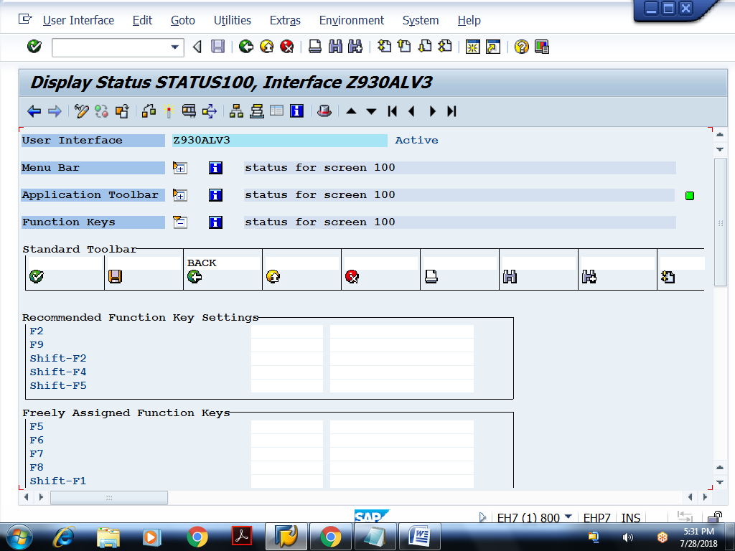

GUI status of screen 200:
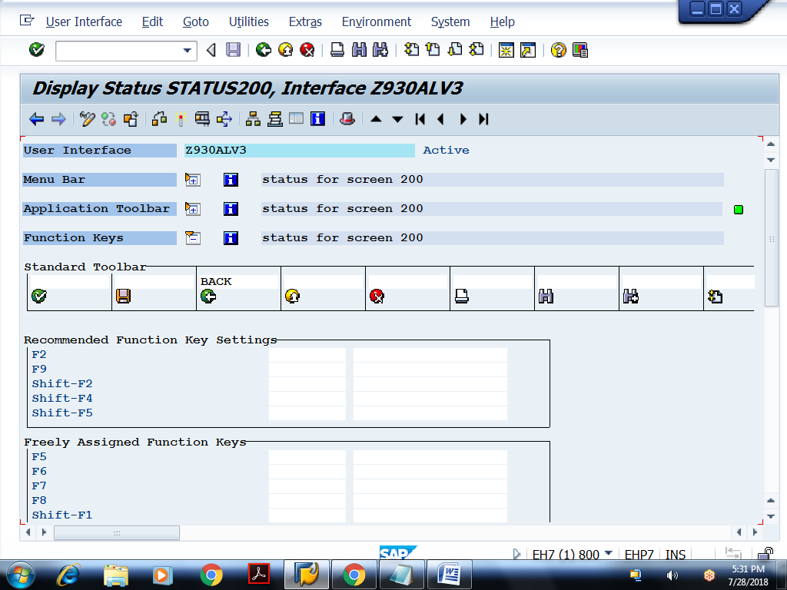
GUI status of screen 300:
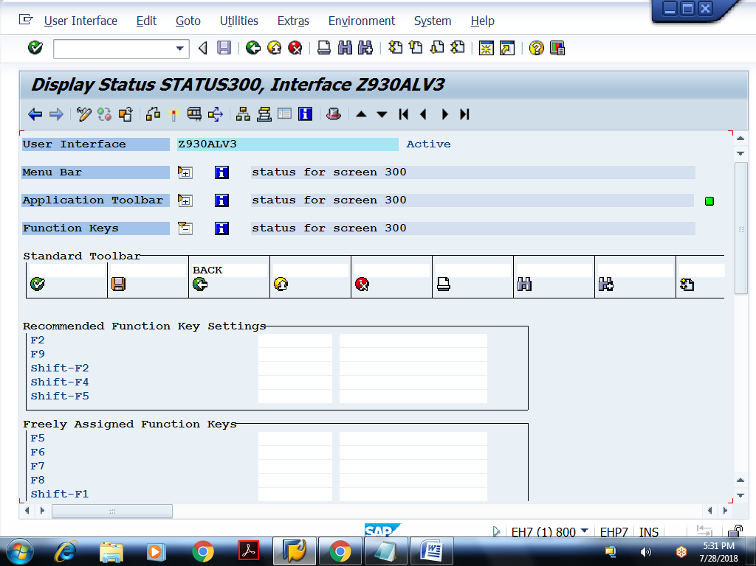
Layout of screen 100:
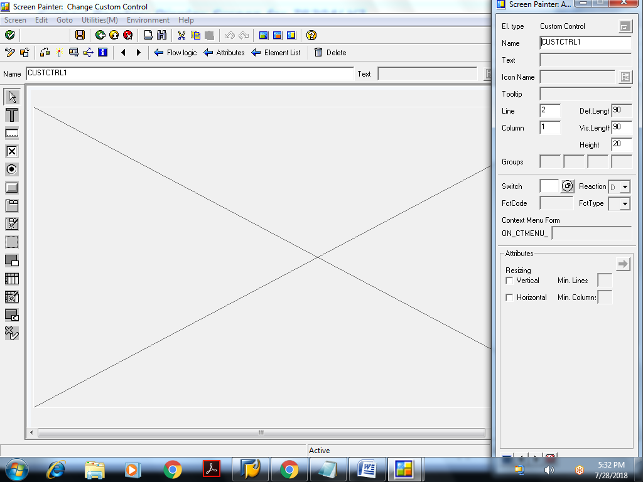
Layout of screen 200:
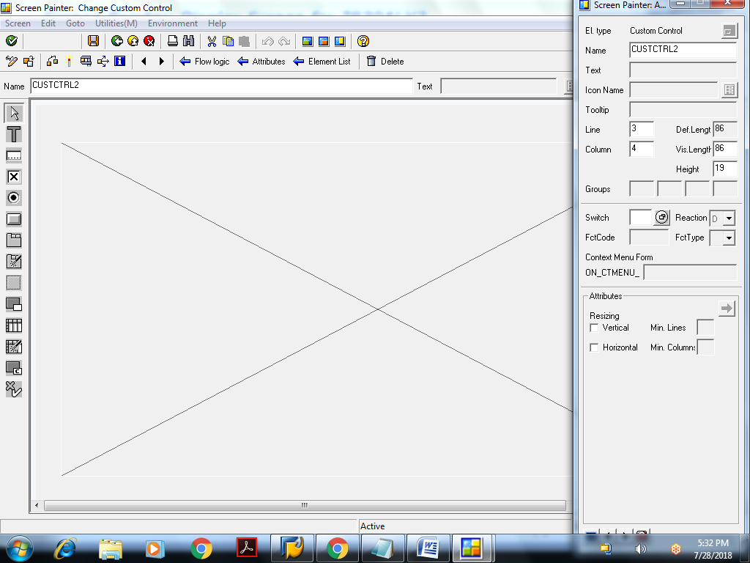
Layout of screen 300:
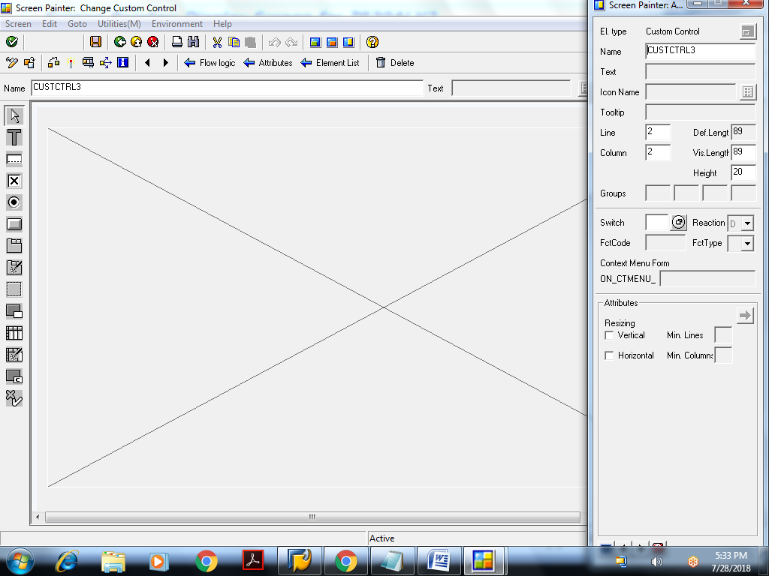
Example: Splitter container
REPORT Z930ALV4.
data : v_vbeln type vbak-vbeln.
select-OPTIONS so_vbeln for v_vbeln DEFAULT '4980' to '4985'.
data : cust_cont type ref to cl_gui_custom_container,
o_split type ref to cl_gui_splitter_container,
o_cont1 type ref to cl_gui_container,
o_cont2 type ref to cl_gui_container,
vbak_grid type ref to cl_gui_alv_grid.
data : t_fcat type lvc_t_fcat,
wa_fcat type lvc_s_fcat.
types : begin of ty_vbak.
include type zcvbak.
types end of ty_vbak.
data : t_vbak type table of ty_vbak,
wa_vbak type ty_vbak.
class lcl_eventreceiver DEFINITION.
public SECTION.
methods handle_toolbar
for event toolbar
of cl_gui_alv_grid.
endclass.
class lcl_eventreceiver IMPLEMENTATION.
method handle_toolbar.
message 'toolbar event' type 'I'.
endmethod.
endclass.
data ob type ref to lcl_eventreceiver.
START-OF-SELECTION.
call screen 100.
MODULE STATUS_0100 OUTPUT.
if cust_cont is not bound.
SET PF-STATUS 'STATUS100'.
* link custom container with custom control
CREATE OBJECT CUST_CONT
EXPORTING
CONTAINER_NAME = 'CUSTCTRL'.
* link splitter container with custom container
CREATE OBJECT O_SPLIT
EXPORTING
PARENT = cust_cont
ROWS = 2
COLUMNS = 1.
* set heights of rows
CALL METHOD O_SPLIT->SET_ROW_HEIGHT
EXPORTING
ID = 1
HEIGHT = 5.
CALL METHOD O_SPLIT->SET_ROW_HEIGHT
EXPORTING
ID = 2
HEIGHT = 8.
* Associate containers for each pane
CALL METHOD O_SPLIT->GET_CONTAINER
EXPORTING
ROW = 1
COLUMN = 1
RECEIVING
CONTAINER = o_cont1.
CALL METHOD O_SPLIT->GET_CONTAINER
EXPORTING
ROW = 2
COLUMN = 1
RECEIVING
CONTAINER = o_cont2.
* get sales orders
perform getvbak.
if t_vbak is not INITIAL.
perform fldcatvbak.
perform displayvbak.
else.
message 'No Sales orders' type 'I'.
endif.
endif.
ENDMODULE. " STATUS_0100 OUTPUT
MODULE USER_COMMAND_0100 INPUT.
case sy-ucomm.
when 'BACK'.
leave program.
endcase.
ENDMODULE. " USER_COMMAND_0100 INPUT
FORM GETVBAK .
select vbeln erdat erzet ernam
from vbak
into table t_vbak
where vbeln in so_vbeln.
ENDFORM. " GETVBAK
FORM FLDCATVBAK .
clear wa_fcat.
wa_fcat-fieldname = 'VBELN'.
wa_fcat-col_pos = 1.
wa_fcat-coltext = 'Sales Doc'.
wa_fcat-outputlen = 15.
append wa_fcat to t_fcat.
clear wa_fcat.
wa_fcat-fieldname = 'ERDAT'.
wa_fcat-col_pos = 2.
wa_fcat-coltext = 'Creation Date'.
wa_fcat-outputlen = 15.
append wa_fcat to t_fcat.
clear wa_fcat.
wa_fcat-fieldname = 'ERZET'.
wa_fcat-col_pos = 3.
wa_fcat-coltext = 'Creation Time'.
wa_fcat-outputlen = 15.
append wa_fcat to t_fcat.
clear wa_fcat.
wa_fcat-fieldname = 'ERNAM'.
wa_fcat-col_pos = 4.
wa_fcat-coltext = 'Person'.
wa_fcat-outputlen = 25.
append wa_fcat to t_fcat.
ENDFORM. " FLDCATVBAK
FORM DISPLAYVBAK .
if vbak_grid is not bound.
* link vbak grid with container o_cont1
CREATE OBJECT VBAK_GRID
EXPORTING
I_PARENT = o_cont1.
* register handlers
perform reghandlers.
CALL METHOD VBAK_GRID->SET_TABLE_FOR_FIRST_DISPLAY
CHANGING
IT_OUTTAB = t_vbak
IT_FIELDCATALOG = t_fcat.
endif.
ENDFORM. " DISPLAYVBAK
FORM REGHANDLERS .
create object ob.
set handler ob->handle_toolbar for vbak_grid.
ENDFORM. " REGHANDLERS
Flow logic of screen 100:
PROCESS BEFORE OUTPUT.
MODULE STATUS_0100.
*
PROCESS AFTER INPUT.
MODULE USER_COMMAND_0100.
GUI status of screen 100:
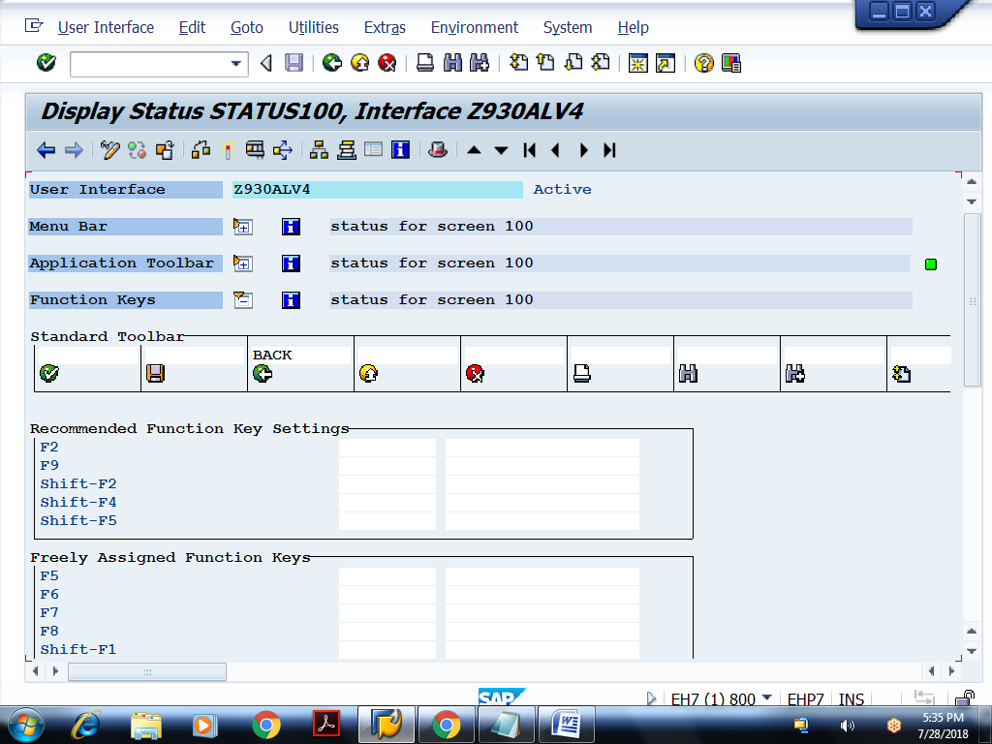
Layout of screen 100:
